My New School
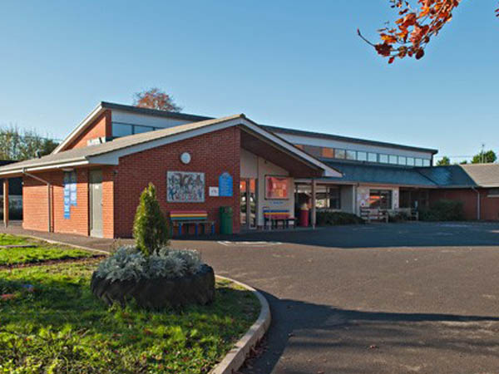
Shrewton Primary School
My class is called Einstein Class
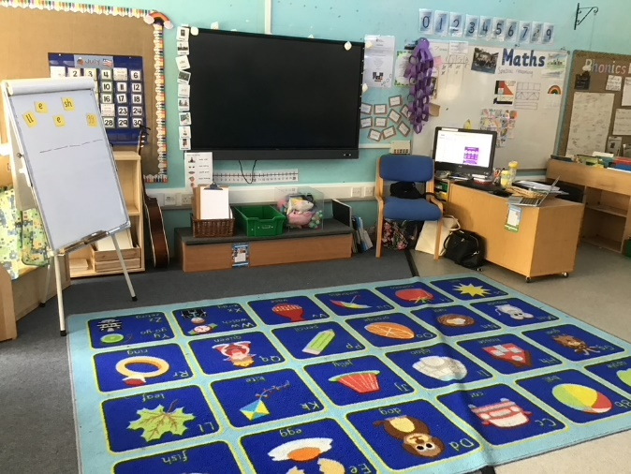
My Class Teacher is called Miss Hill
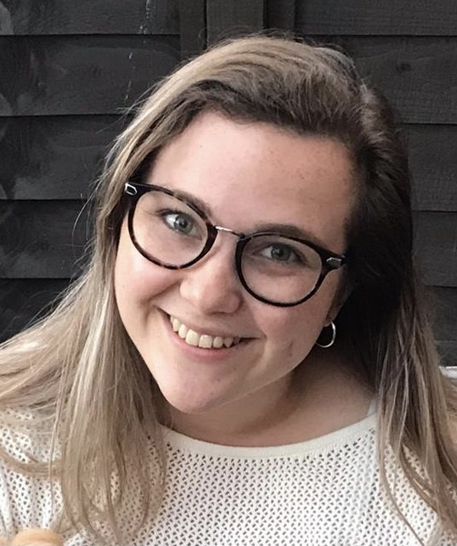

The class Teaching Assistant is Mrs Jackson
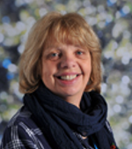

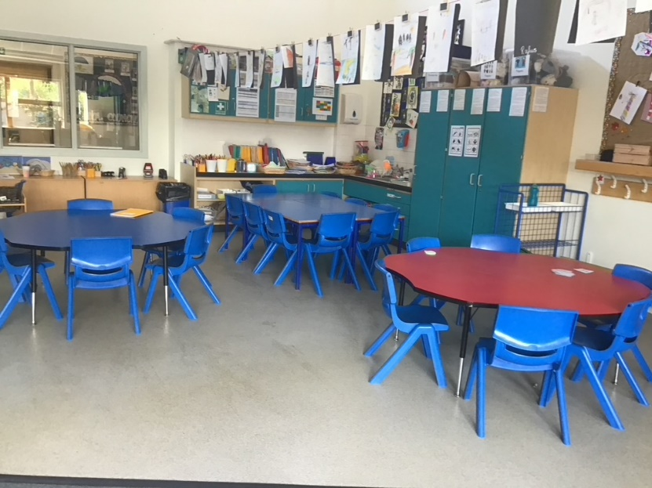
I will sit at one of these tables to do some fun learning activities for my Phonics and Maths…
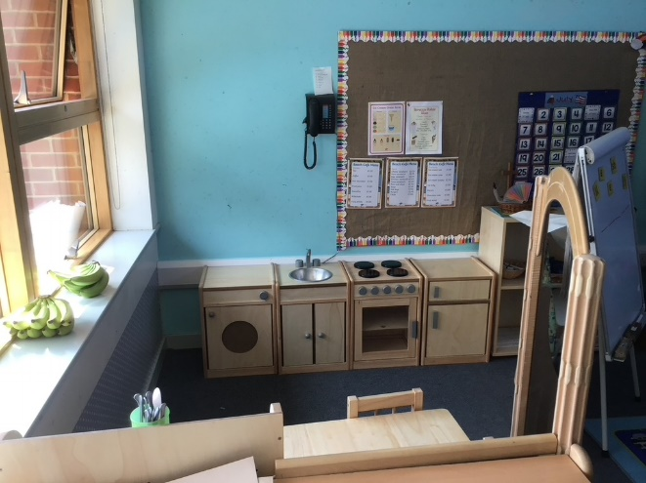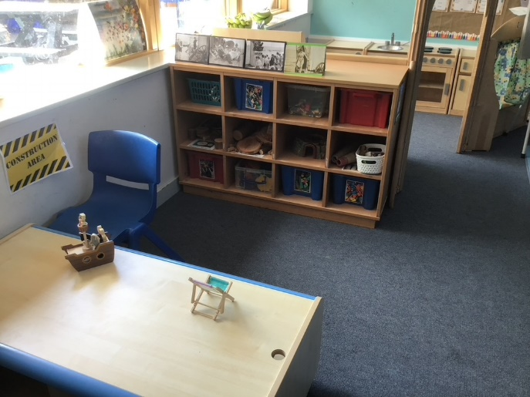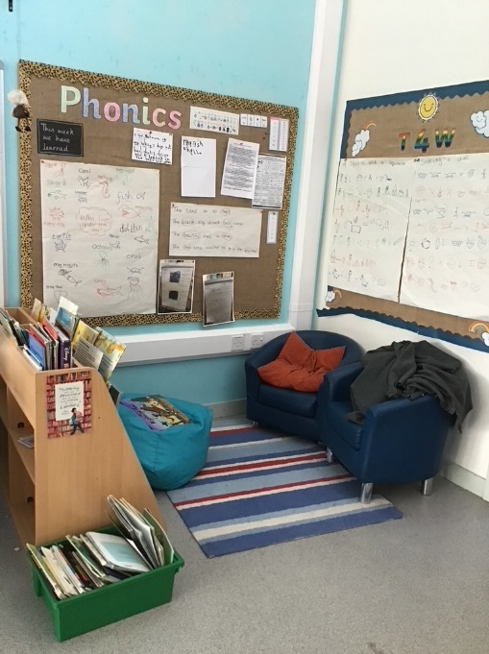
or explore these areas during Discovery time
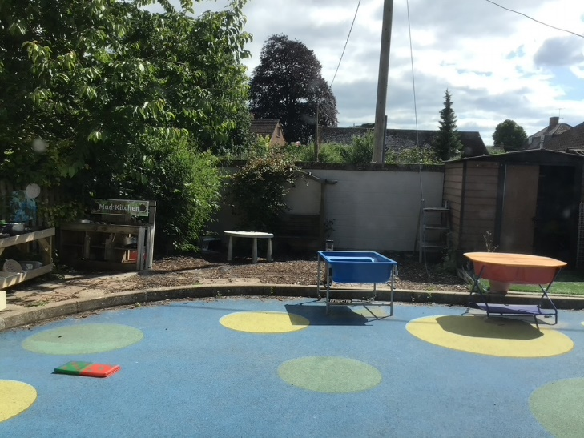
This is the outside learning area

I Will have lots of fun and learn lots of new and exciting things. Also I will make new friends and meet some new people. 
This Photo by Unknown Author is licensed under CC BY-SA

Other Adults there to help me
Mrs Mullord (Head Teacher)

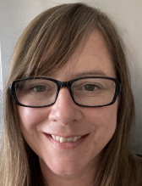

Miss Korbey (DAHL class teacher & School ELSA)
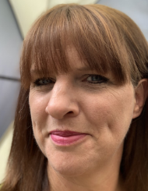

Mrs Williams (SEN Teaching Assistant).
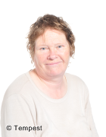
Mrs Fieldhouse – Lunchtime Assistant.

