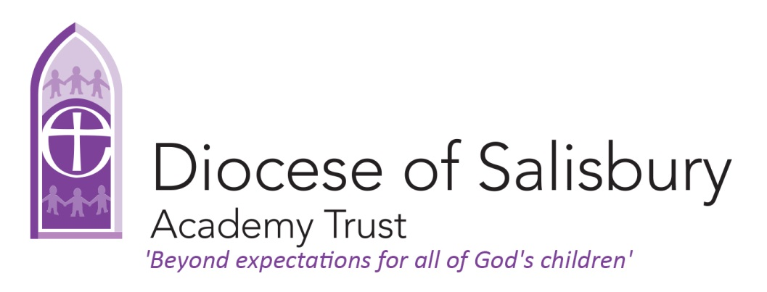
Beyond Expectations – English Mastery
How to develop an English mastery pathway in our school
Reviewed on: | 1/5/2019
Next review: | 15/2020
Staff responsible: | M Halton
Governor responsible
Signed by chair:

What is a mastery in English?
The English curriculum at Shrewton Primary has taken many of the content and principles of ‘Mastery’ in mathematics. We have developed a curriculum which ensures children spend longer being taught the common features and skills in reading and writing in order to have a more coherent English curriculum and therefore be able to develop mastery in English. The curriculum has been adapted using various methods such as: talk for writing, having a strong grammar focus, using high quality novels and books as well as using a range of drama conventions.

Statutory guidance
‘Teachers should develop pupils’ spoken language, reading, writing and vocabulary as integral aspects of the teaching of every subject. English is both a subject in its own right and the medium for teaching; for pupils, understanding the language provides access to the whole curriculum. Fluency in the English language is an essential foundation for success in all subjects.’ National Curriculum 2014.
Effective communication, both spoken and written, is a priority at Shrewton for all pupils. We plan teaching opportunities to help those for whom English is an additional language and those with disabilities outlined in the SEN Code of Practice.

Objectives:
In English, our main aim as a school is for all children to develop a love of reading as well as the necessary skills needed in writing for life and also be able to have access to future learning.
English is taught in mixed ability groups for the majority of the time as we believe all children can achieve. In this approach, all children are exposed to some higher-level thinking questions and problem-solving as well as having the opportunity to collaborate and develop a growth mind-set through working with their peers.
Additional intervention is provided for children working below age expectations in reading, along with extension activities and questions for children working at greater depth.

Principles:
- Teachers reinforce an expectation that all pupils are capable of achieving high standards in English.
- The large majority of pupils progress through the curriculum content at the same pace. Differentiation is achieved through additional support and encouraging children’s individual flair and fluency.
- Interventions focus on gaps in knowledge and developing a growth mind-set in order to ensure all children achieve.
- Teaching is underpinned by using high quality texts and high quality examples from the teacher which focus on skills to be taught. These texts are then analysed in depth with the children in order for them to learn and apply those skills.
- Grammar and punctuation skills are practiced and consolidated until all children have a firm understanding of how to apply them in to their own work.

Design:
A carefully considered teaching cycle is followed throughout the school with engaging theme titles taken from Cornerstones. High quality, topic related, texts are approached with a Talk 4 Writing ethos. Example texts are mapped, learned, retold, interrogated, deconstructed and toolkits are constructed from what is found. This aids children to understand the structure and mechanics of writing. This is followed by shared and modelled writing with the teacher, which helps to nurture the children’s fluency and creativity. The children then apply their skills in independent pieces of writing which are finally edited and improved by the individual child as well as receiving some input from their peers. Throughout the process, the children are taught to read as writers and write as readers.
Lessons are carefully planned using input from other teachers and teaching assistants in daily feedforward / feedback meetings, drawing on evidence from observations of pupils in class. Lesson designs are carefully considered to ensure that the children are taught the concepts and structures needed to become competent writers. Children are often given a real purpose to write and the units often have hooks in order to engage and inspire the children’s thinking and learning.

We believe that children learn best when:
Learning activities are well planned, ensuring progress in the short, medium and long term.
Activities enthuse, engage and motivate them, fostering their curiosity and enthusiasm.
Assessment informs teaching so that there is provision for support, repetition and extension of learning for each child, at each level of attainment
There are strong links between home and school, and the importance of parental involvement in their children’s learning is recognised, valued and developed

Children learn best when learning activities are well planned, ensuring progress in the short, medium and long term
There will be evidence in the learning environment of:
- Differentiation offering all children the opportunity to make progress in English learning
- Current English learning related to specific objectives and contextualised learning
- Exemplified text types and writing units
- Banks of vocabulary and working wall based display to support children’s learning
- Children being engaged through a wide range of activities
- Modelled expectations available for reference
- Easily accessible reference material such as word mats, dictionaries and thesauruses

- Teachers will ensure that:
- Planning covers all English objectives across the year
- Discrete English skills and knowledge are developed daily
- Topics offer children the opportunity to contextualise and apply literacy skills for a wide range of purposes
- Writing is edited and published for display or another purpose at least once every half term
- Learning is differentiated for different abilities
- Long term planning covers the full range of writing purposes and assessment foci
- Planning builds on most recent assessment
- Children’s prior skills, experiences and knowledge are valued and incorporated into the learning

Implications for the whole school:
- English objectives for spoken language, drama, reading and writing are tracked on SPTO and covered throughout the year
- A monitoring cycle is in place to support the progress of individuals and groups of learners through planning scrutiny and book-looks

Children learn best when activities enthuse, engage and motivate them, fostering their curiosity and enthusiasm
There will be evidence in the learning environment of:
- English embedded in all curriculum areas
- Current cross-curricular work and relevant vocabulary
- Children developing an understanding of concepts and the vocabulary required to describe and explain them
- Children experiencing learning through a range of media, formats and activities
- Children having the opportunity to investigate and explore
- Opportunities for children to explore language through speaking, listening and drama activities
- Children being encouraged to discuss their work in partner and group situations. This is modelled and structured for the children
- Reading and writing skills being modelled and exemplifications displayed

- Teachers will make sure that:
- The timetable offers regular opportunities to cover guided reading, spelling, phonics, handwriting and cross-curricular writing

Implications for the whole school:
- Quality resources are available to support English and cross-curricular work
- Hooks, trips, workshops, visiting artists and other motivational ways of working are planned half-termly
- Planning shows an outcome led process with development of skills

Children learn best when assessment informs teaching so that there is provision for support, repetition and extension of learning for each child, at each level of attainment
There will be evidence in the learning environment of:
- Differentiation through a variety of opportunities such as flexible groupings, outcomes, resources and challenge activities
- Marking which reflects acknowledgement of achievement at all levels and supports children’s progress through next step marking to which children respond.

- Teachers will make sure that:
- Learning objectives are derived from the curriculum and are differentiated
- Short term planning is flexible and reflects assessment

Implications for the whole school:
- Reading and writing evidence across the school is moderated, teacher lead assessment and best practise is shared.

Children learn best when there are strong links between home and school, and the importance of parental involvement in their children’s learning is recognised, valued and developed.
There will be evidence in the learning environment of:
- Children being encouraged and supported to read at home. For example through Read Theory and Race To The Middle.
- Home learning offering opportunities for research and writing as well as discussion points for conversation

Teachers will make sure that:
- Home reading is encouraged through our ‘star reader’ rewards system, the running of book fairs and visiting volunteer readers
- Children and parents know when reading books are changed and how to use the reading record books
- Home learning is displayed to celebrate research and writing
- Teachers provide book list suggestions for each age group to parents at parent consultations

Implications for the whole school:
- All classes have well-stocked reading areas
- All classes use reading records
- Teachers display what they are reading personally on classroom doors
- Each class has a class book read to them selected from the Pie Corbett reading spine to ensure it is appropriately challenging and to eliminate repetition of titles.
- The Pie Corbett reading spine* provides age appropriate, high quality text suggestions for each group which class teachers can read as their class book. Teachers read to the whole class from the class book at least twice a week.
* https://images.scholastic.co.uk/assets/a/9f/bc/pie-corbett-with-page-no-1393983.pdf

Additional information
This policy needs to be read alongside other school policies including:
- Homework
- Early Years Foundation Stage
- Gifted and Talented
- Special Needs
- Assessment
- Marking and Feedback

This policy should also be read alongside the National Curriculum and other documents from the Standards and Testing Agency.

Monitoring and review
Monitoring of the standards of children’s work and the quality of teaching in English is the responsibility of the subject leaders. The work of the subject leader also involves supporting colleagues in their teaching, being informed about current developments in the subject, and providing a strategic lead and direction for English in the school. The subject leader gives the head teacher an action plan each year outlining the actions that have been taken, the progress that has been made and the next steps. The named governor responsible for literacy meets regularly with the subject leader in order to review progress.

Guidance for Spoken Language
The National Curriculum states that pupils should be ‘taught to speak clearly and convey ideas confidently in Standard English’. They should:
- Justify ideas with reasons
- Ask questions to check understanding
- Develop vocabulary and build knowledge
- Negotiate
- Evaluate and build on the ideas of others
- Select the appropriate register for effective communication
- Give well-structured descriptions and explanations
- Speculate, hypothesise and explore ideas
- Organise their ideas prior to writing

Our aims:
To enable our children to speak with clarity, confidence and expression, and to take account of their audience, purpose and differing situations.
To encourage our children to listen with concentration to others, to respond and build on their ideas and opinions and to identify features of language used for specific purposes.
To show our children how to adapt their speech to a wide range of circumstances and demands by giving them the opportunity to listen and respond to literature, give and receive instructions and develop the skills of participating effectively in group discussions.
Examples of what we do:
- Employ talk4Writing
- Provide a range of opportunities for children to talk and listen in formal and informal settings
- We use role-play and drama activities to explore situations e.g. hot-seating
- Listen to a range of poetry and rhyme
- Regular story times
- PSHE and Circle Time
- Class/group debates
- We share experiences, ideas or describe events/objects
- Interviewing
- Opportunities to extend our vocabulary (new words walls)
- Use of audio and visual recording
- Opportunities to take part in performances

Guidance for Reading
The National Curriculum states that ‘all pupils must be encouraged to read widely across both fiction and non-fiction to develop their knowledge of themselves and the world in which they live, to establish an appreciation and love of reading, and to gain knowledge across the curriculum.’
The Curriculum divides reading skills into two dimensions:
- Word reading
- Comprehension

We recognise that both these elements are essential to success and we support these in a variety of ways. Reading begins in Foundation Stage through sharing books with simple or no text so that the children can learn how to tell a story using images. Children progress through the reading bands accordingly with each book level introducing new reading and comprehension skills. There is an emphasis on children learning to decode through daily phonics teaching and developing their sight vocabulary for common exception words. Comprehension skills are taught in guided reading session. Parents are encouraged to support their child to develop a love of reading through training sessions, book week activities, open classroom modelled reading sessions and one to one meetings with teachers.

Reading strategies are established through Guided Reading sessions which happen daily. In small groups with their class teacher, Guided reading provides an opportunity for the teacher to teach reading in relation to the differentiated needs of the pupil groups and their level of achievement. Use of reading ages, Lexile levels, phonics scores and comprehension assessments are alloyed to ensure groupings receive appropriately challenging texts with which to work. Children who do not progress at the expected rate are supported with reading intervention.

Our aims:
To enable our children to learn to read easily and fluently through the use of phonological awareness to decode and encode words
To help them to be able to read with fluency, accuracy, understanding and enjoyment so that they become independent and reflective readers
To provide a well-resourced, attractive school library which supports and extends teaching and learning across the curriculum

Examples of what we do:
- Guided reading sessions occur at least 4 days per week with children grouped according to data from Puma comprehensions, SPTO, Read Theory and teacher assessment
- Guided reading learning objectives are planned and results recorded on a planning grid*
- Daily ‘Letters and sounds’ phonic and/or spelling sessions across the school
- Children are given opportunities for regular reading to adults in school and more often for those who may not get support from home
- Pupils are encouraged to read widely, through our use of differing class texts, library visits, Read Theory and high quality attractive books in classrooms
- Pupils are encouraged to read for pleasure using reading partners, quiet reading time and listening to an adult read
- Ensuring that all children have a regular period of quiet reading daily, practised also by the teacher to provide a role model of reading for enjoyment
- Using a home-school reading diary and rewarding regular reading at home through our Star Readers certificates
- The use of a variety of reading games including the use of ICT resources
- The use of directed activities related to text (such as completing cloze procedures, quizzes and book reviews)
- Provide good role-models by telling children about our favourite children’s books or parts of stories and display what we are reading on classroom doors
- Encouraging discussion about favourite stories, books and other texts
- The phonics buddies system pairs KS2 children with year 1 children to work on focussed phonics games each day at the end of lunch play.
- Continually relating the age appropriate elements of spelling, punctuation and grammar back to the guided reading text deepens learning and yields more accomplished writing in turn.

We incorporate the eight strands from the reading curriculum (word reading, inference, clarify, respond and explain, monitor and summarise, themes and conventions, language for effect, select and retrieve) in our teaching
- We provide resources to support adults and children to ask and answer quality questions
- We provide opportunities for children to read and respond (orally and in writing) to excerpts from familiar and unfamiliar texts

*
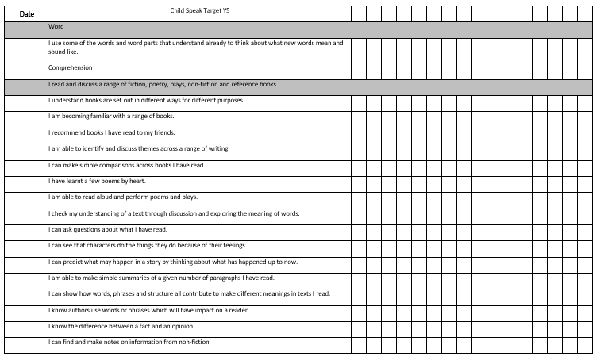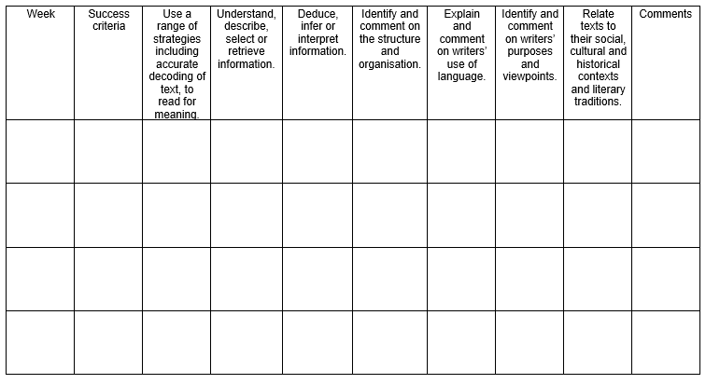

Guidance for Writing
The National Curriculum states that pupils should:
- Develop the stamina and skills to write at length
- Use accurate spelling and punctuation
- Be grammatically correct
- Write in a range of ways and purposes including narratives, explanations, descriptions, comparisons, summaries and evaluations
- Write to support their understanding and consolidation of what they have heard or read

The 2014 Curriculum divides writing skills into two dimensions:
- Transcription (spelling and handwriting)
- Composition (articulating ideas in speech and writing)

We recognise that both these elements are essential to success and we support these in a variety of ways.
Our aims:
To help our children develop an understanding that writing is both essential to thinking and learning and enjoyable in its own right.
For children to be able to write sentences using a range of different structures
For children to articulate and communicate their ideas, and organise them coherently for a reader
For children to be able to spell and punctuate accurately and create grammatically correct sentences
To enable them to improve their planning, drafting and editing skills

Examples of what we do:
- Following the Talk4Write model, we begin with a cold write (which informs planning) and assess with a hot write at the end of a unit
- High quality model texts support each unit and are deconstructed by children to form toolkits which they then use in the writing phase
- Teach specific grammatical skills discretely in SPAG sessions which link to the writing of the day
- Valuing children’s writing at all stages thus encouraging children to see themselves as writers from early on
- Providing real purposes for writing, enabling children to become increasingly aware of their intended audience
- A multi-sensory approach providing a range of contexts and stimuli
- The use of drama skills, e.g. hot seating, re-enacting, use of the theatre
- Providing a role model through the teacher sharing their own writing processes
- Opportunities for collaborative writing and use of writing frames where appropriate
- Giving children experience of a range of ways to plan so they can choose which is appropriate for their needs as they progress through the school
- Provide time for planning, editing and revising
- Mark extended pieces of work in-depth and set targets with the pupil
- Opportunities for self and peer assessment
- Encourage children to develop their own legible, fluent style of handwriting
- Support pupils with learning and motor difficulties
- Use of Letter Join to promote a consistent approach across school

Guidance for Vocabulary
The National Curriculum states that ‘opportunities for teachers to enhance pupils’ vocabulary arise naturally from their reading and writing. Teachers should show pupils how to understand the relationships between words, how to understand nuances in meaning, and how to develop their understanding of, and ability to use, figurative language.’
Vocabulary teaching needs to be:
- Ongoing
- Progressive and systematic
- Making links from known words
- Develop understanding of shades of meaning
- Subject specific - accurate mathematical and scientific words

Our aim:
For all children to develop a wide and varied vocabulary and be able to use these words in context
Examples of what we do:
- Spelling lists/key words to take home and learn
- Display of key words linked to topics and subjects
- Opportunities for ‘pre-learning’ of new vocabulary before a new topic is begun
- Using the correct vocabulary orally
- In-depth word based lessons looking at patterns
- Using dictionaries and thesauruses
- Using high quality texts to explore vocabulary choices and the effect they have
- Vocabulary wall displaying the new and interesting words that have been explored in class
- Desk mats of key words
- Spelling bee
- Weekly spelling tests

Foundation Stage
Teachers in the Foundation Stage follow the Communication and Language strand and Literacy strand of the Early Years Foundation Stage (EYFS) Framework April 2017.
By the end of the Foundation Stage children should: ‐
- Listen attentively in a range of situations.
- Listen to stories, anticipate key events and respond with relevant comments, questions or actions.
- Give attention to what other say and respond appropriately, while engaged in another activity.
- Follow instructions involving several ideas or actions.
- Answer ‘how’ and ‘why’ questions about their experiences and in response to stories or events.
- Express themselves effectively, showing awareness of the listeners’ needs.
- Use past, present and future forms accurately when talking about events.
- Develop their own narratives and explanations by connecting ideas or events.
- Read and understand simple sentences.
- Use phonic knowledge to decode regular words and read them aloud accurately.
- Read some common irregular words.
- Demonstrate understanding when talking with others about what they have read.
- Use phonic knowledge to write words in ways which match their spoken sounds.
- Write some irregular common words.
- Write simple sentences which can be read by themselves and others.
- Spell some words correctly and other in a phonetically plausible way.

(EYFS profile 2017)

