**The Shrewton Approach to Maths and**

**Mastery**

**Curriculum Intent**

Mathematics is a **creative** and highly inter-connected discipline that has been developed over centuries, providing the solution to some of history’s most intriguing problems. It is essential to everyday life, critical to science, technology and engineering, and necessary for financial literacy. Crucially, a sound knowledge of mathematics is **vital** for young people seeking employment, and securing a qualification in mathematics is a fundamental requirement for the majority of employers.

A **high-quality mathematics education** therefore provides a **foundation for understanding the world**, the **ability to reason mathematically**, an appreciation of the beauty and power of mathematics, and a sense of **enjoyment** and **curiosity** about the subject.

In line with the National Curriculum Objectives for Mathematics, our intent is that all pupils:

* become **fluent** in the fundamentals of mathematics, including through **varied and frequent** practice with increasingly complex problems over time, so that pupils **develop conceptual understanding** and the ability to **recall and apply** knowledge **rapidly and accurately**
* **reason mathematically** by following a line of enquiry, conjecturing relationships and generalisations, and developing an argument, justification or proof using **mathematical language**
* can **solve problems** by **applying** their mathematics to a **variety of routine and non-routine problems** with increasing sophistication, including breaking down problems into a series of simpler steps and **persevering** in seeking solutions

In order for our pupils to make rich connections, using mathematical thinking to problem solve through a variety of problems displayed in various ways – we know that a focus on fluency is vital as concrete knowledge in the mathematical basics will allow our pupils to thrive in all areas of the Maths curriculum. In order for us to achieve this we have introduced ‘Fluent in 15’ a push on fluency skills at the start of every Maths lesson and beyond. Further to this, we have introduced a new scheme called ‘Number Sense’ which leads pupils from EYFS through to Y3 on a journey through the key facts to enable concrete understanding of the fluency skills needed to be successful in all mathematical concepts. From Y3 through to Y6 the scheme follows suit with times table fluency. This scheme is new to us, however we have already seen parts of its success and look forward to the future of its use.

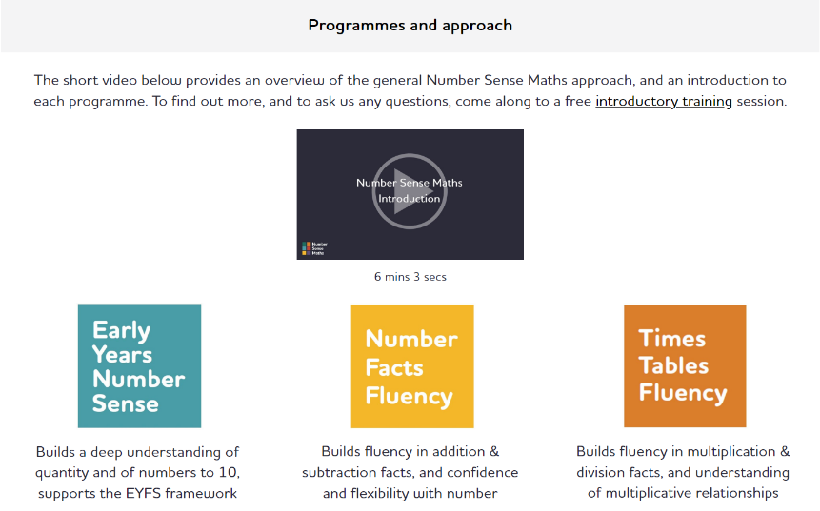

Central to our approach are the **5 Big Ideas** which underpin mastery in mathematics.

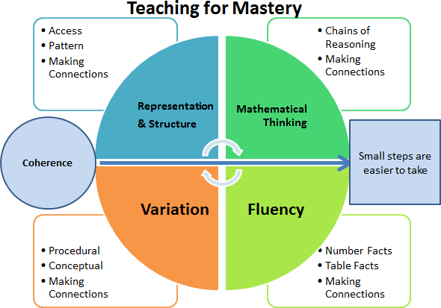

In line with our focus of Oracy, we also expect and encourage children to use **mathematical language** to **describe, discuss, examine, explain, justify and synthesize**.

**Curriculum Implementation**

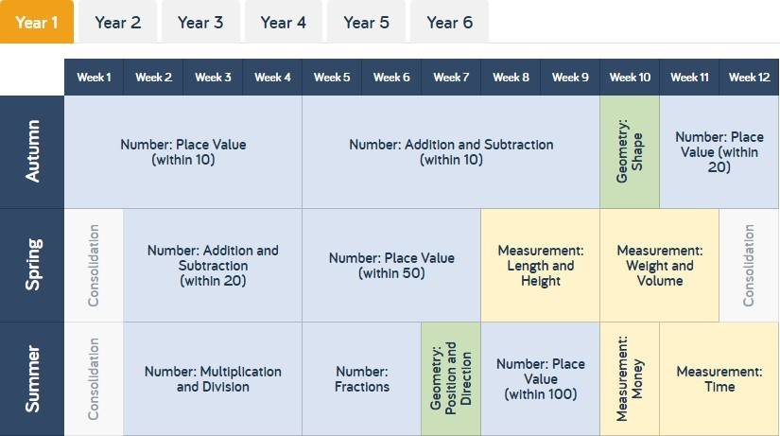



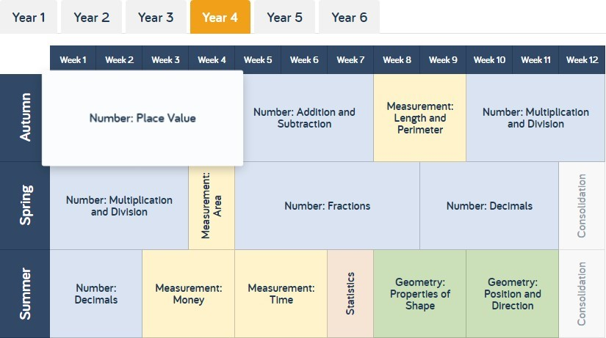

**Key Pillars of our Mastery Approach**

**Concrete, Pictorial and Abstract Learning**

Children engage with a wide and varied range of concrete manipulatives, pictorial representations and abstract methodologies within each session. **Cohesive** use of CPA is a fundamental part of mastery in mathematics for all learners, not just those pupils with SEND. Concrete and pictorial references scaffold and strengthen understanding and are widely used as a teaching and learning tool from Foundation Stage to Year 6.

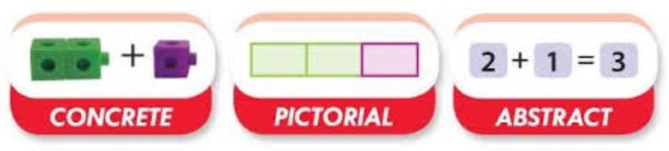

**Fluency, Reasoning and Problem Solving**

Every learning session includes the opportunity to develop fluency skills, construct chains of reasoning using relevant knowledge alongside relevant terminology and solve increasingly complex problems in a **systematic and coherent** way.

**Mathematical Vocabulary**

Sessions include explicit reference to vital **mathematical vocabulary** and the use of **stem sentences** to support and encourage all children to communicate their ideas with mathematical precision and clarity. These sentence structures often express key conceptual ideas or generalities and provide a framework to embed conceptual knowledge and build understanding.

**Interleaved Learning to Automaticity**

WRM is a blocked learning scheme and as a consequence certain strands of maths are not covered until later in the term. To ensure frequent timely introduction and revisiting of **concepts**, we plan and deliver interleaved learning sessions as part of our daily taths timetable where we begin with our **‘fluent in fifteen’** sessions, creating the opportunity to rehearse and apply fluency learning to lead to **automaticity**. We do this through revisiting four areas informed by teacher assessment and our **fluency progression**: calculation, counting, number facts and wild card (teacher’s choice).

**Fluent Recall**

We are committed to ensuring that pupils secure their **knowledge** of Times Tables and Related Divisional Facts by the end of Year 4. Our pupils engage in regular low stakes testing through Times Tables Rock Stars to practice **fluent recall**.

**Journaling**

The use of journaling supports our approach and enables our mathematicians to build a web of **schema** where they **can identify and link together multiple methods and patterns** to fully embed mathematical understanding. Maths journals provide learners the opportunities to **communicate** their thoughts and ideas and give an insight into how children are thinking whilst providing evidence of their developing understanding. There are 5 types of journaling that we use: **descriptive, evaluative, creative, investigative and formative.**

**EYFS**

Our Early Years approach places a significant emphasis on developing a strong grounding in number – understanding that this is a necessary building block for children to excel in the subject.

The two key ELG’s for mathematics are:

* Number: Number composition, subitising, recall of bonds to 5 and 10 and doubling
* Numerical Pattern: Verbally count beyond 20, Compare quantities, explore and represent patterns

Practitioners provide creative and engaging opportunities for children to ignite their curiosity and enthusiasm for the subject, while focusing on the three prime areas of: Communication and Language, Physical Development and PSED.

We follow NCTEM’s Mastering Number and children take time to learn about one number at a time focussing on different structures and representations of that number. Activities and experiences are frequent and varied, and allow children to build on and apply understanding of Numbers to 10. Concrete manipulatives are a key focus within sessions, as is the use of pictorial representations including Tens Frames and Part/Whole Models. Children are actively encouraged to use mathematical terminology within their understanding, with a focus on developing positive attitudes and interest in the subject.

**Our Maths Lesson**

**The Planning**

* Long Term planning will be provided by Maths Leader (taken from White Rose Overviews)
* Medium Term planning will take the form of S-planning or White Rose Small Steps
* Weekly Planning is constructed by teachers using the rationale above. Further support may be sought from Number Sense, NRICH, Maths No Problem, Numicon planning documents etc. **Our priority is to ensure the 5 principles of mastery.**

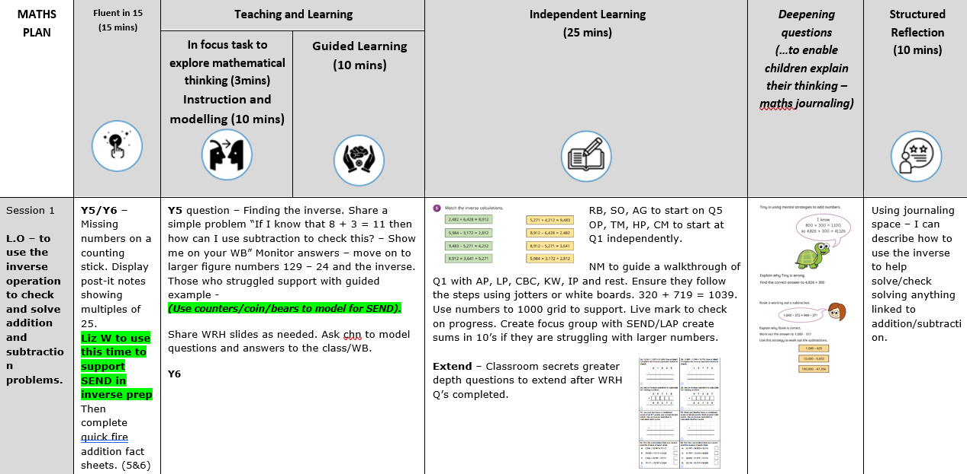

**The Books**

* Each lesson has a LO and short date, in KS1 the LO contains number formation revision, an independent fluency task, a journaling space and mastery opportunities.
* 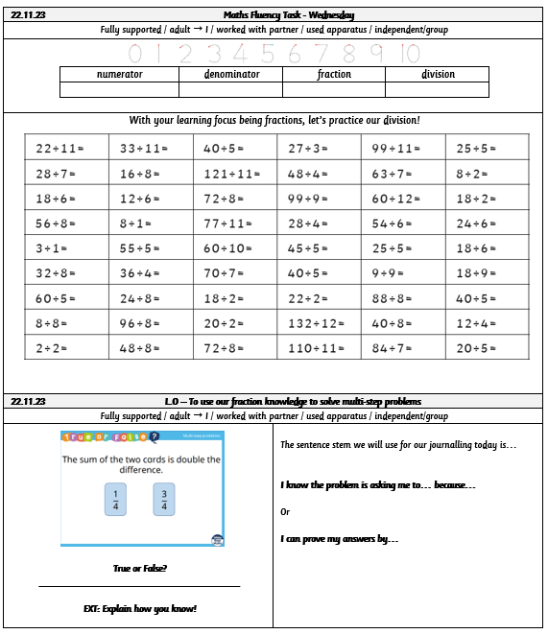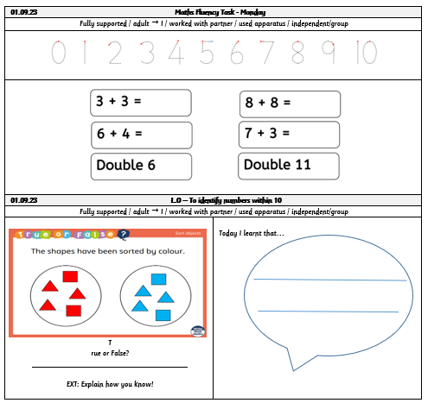Any additional challenges should be trimmed and stuck in before completion.
* Maths journaling throughout the lesson and during the plenary are to be modelled by the teacher, then supported by the teacher and, ultimately, independently and naturally completed by the children. Using comment tracking layout. The children should be confident in using supportive and structured sentence stems to allow them to reason and journal effectively.
* Individual books for journaling/maths practice are provided to encourage active learning.

**Individual Lessons**

Fluent in Fifteen 

Structured Reflection  

Guided Learning 

Stretch and Deepen Understanding 

Independent Learning 

**Fluent in Fifteen (example)**

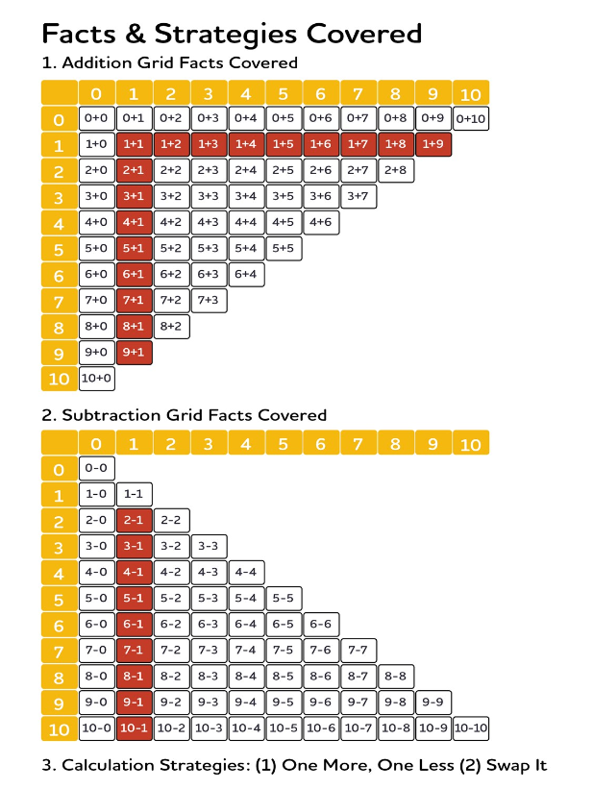

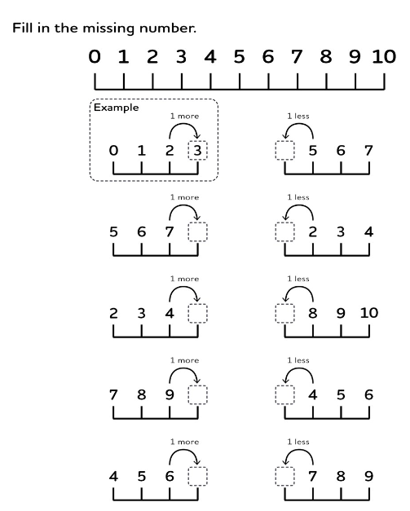

**Curriculum Impact**

The expectation is that the majority of pupils will move through the programmes of study at broadly the same pace. We aim for each child to be confident in each yearly objective and develop their ability to use this knowledge to develop a greater depth understanding to solve varied fluency problems as well as problem solving and reasoning questions.

However, decisions about when to progress should always be based on the security of pupils’ understanding and their readiness to progress to the next stage. Pupils who grasp concepts rapidly are challenged through rich and sophisticated problems before any acceleration through new content. Those who are not sufficiently fluent with earlier material consolidate their understanding, including through additional practice, before moving on. Where necessary, earlier material should consolidate their understanding, including through additional practice, before moving on.

**Formative Assessment**

Teachers carry out formative assessment through AfL in each session and feedback is given to children verbally, through self/peer assessment and through marking.

Teachers then use this assessment to influence their planning. Children are rapidly identified as needing further challenge or additional support, and we ensure that this is provided in a timely manner.

**Timely Interventions**

Teachers believe that all children can achieve in maths, and focus on whole class teaching. Where prerequisites are not secure, timely interventions will be carried out. We understand that catch-up does not work, and as a consequence our interventions are focused on Pre-Teaching and Same Day Interventions.

**Low Stakes Quizzing and Fluent Recall**

We use a range of low stakes testing throughout the teaching cycle to assess attainment and progress. From Year 2 to Year 6, children complete regular tests in Arithmetic and Times Tables.

**Summative Assessments**

Children complete End of Block assessments for each phase of learning. Results are used to further inform planning and allow for tailored interventions groups to take place to ensure the objectives are secured.

Our Assessment Calendar also includes 3 key dates for capturing progress and attainment against National Curriculum Objectives. Assessments are carried out in Autumn, Spring and Summer terms and these are informed by our PUMA Rising Stars papers.

**Subject Monitoring**

We regularly monitor the quality and impact of our mathematics curriculum through targeted learning walks, book scrutiny and pupil interviews. In addition to this, we survey our staff and pupils to identify their perception of mathematics and identify CPD needs.

**Fluency Progression and Skills**

